Before you begin…..

Attached are the instructions for the USAS system to automatically assign the transaction (receipt) numbers (the transaction numbers will not be entered in on the spreadsheet).

The instructions on the following two pages may be given to your staff. You may customize steps 2 and 3 for your district (how to name the file, where to save the file and who to email the file to).

If a date is not entered on the spreadsheet, the date entered in the Posting Date field in AUTOPOST will be the assigned date.

If a date is entered on the spreadsheet, it will override the date entered in the Posting Date field in AUTOPOST. If you want the date taken off of the spreadsheet, please email fiscal_help@sparcc.org
Using Excel to Load Reduction of Expenditures
(System Assigns Transaction Numbers)

If the USAS system is automatically assigning the transaction number, the fields in the Excel template must be filled in as follows:

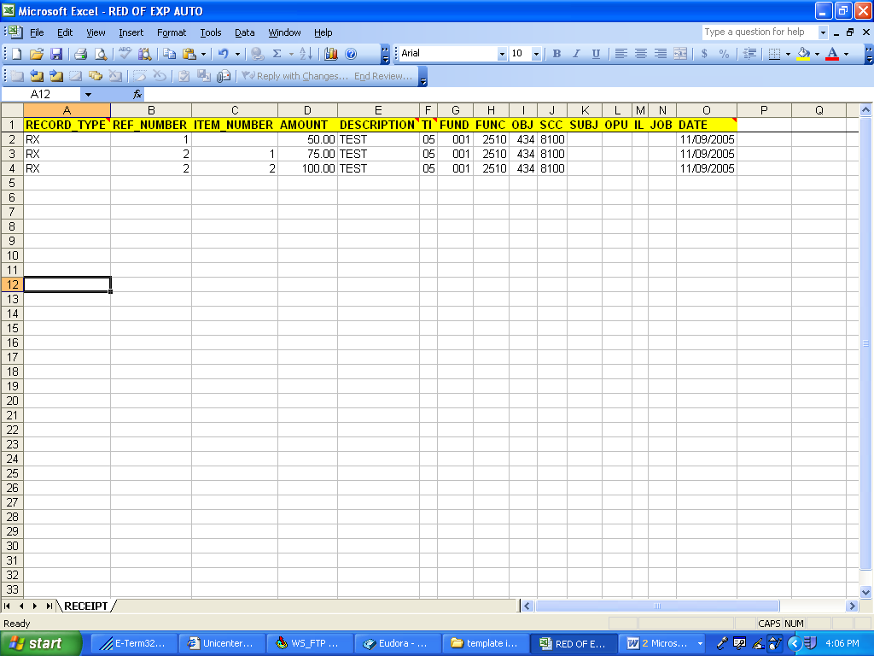

RECORD_TYPE: Enter RX. Must be uppercase.

REF_NUMBER: Enter a 1 for the first reduction of expenditure, a 2 for the second, etc. If there are multiple item numbers for one reduction of expenditure, the transaction number remains the same (see example for REF_NUMBER 2 above).

ITEM_NUMBER: If entering more than one item for a reduction of expenditure, this must be filled in accordingly. This may be left blank if there is only one item per transaction number.

AMOUNT: Enter in the item amount of the reduction of expenditure.

DESCRIPTION: Enter in the reduction of expenditure description.

TI: Enter 05 for a reduction of expenditure. Make sure the leading zero appears.

FUND: Enter in the fund code. Make sure the leading zeroes appear.

FUNC: Enter in the function code. It must be 4 characters in length.

OBJ: Enter in the object code. It must be 3 characters in length.

SCC: Fill in if applicable. If data is entered, it must be 4 characters in length.

SUBJECT: Fill in if applicable. If data is entered, it must be 6 characters in length.

OPU: Fill in if applicable. If data is entered, it must be 3 characters in length.

IL: Fill in if applicable. If data is entered, it must be 2 characters in length.

JOB: Fill in if applicable. If data is entered, it must be 3 characters in length.

DATE: Fill in if applicable. Must be entered as MM/DD/YYYY (slashes must be entered).

- Once you have entered all of the data in to the spreadsheet, you must do a File, Save As:
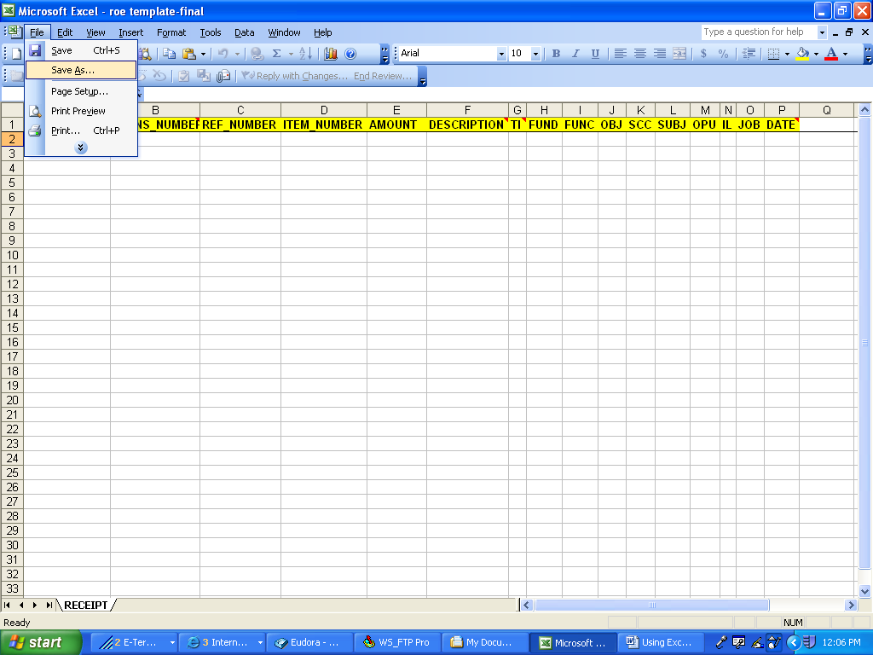

- Name the file accordingly (HS11052005) and save as an Excel file (note where you are saving it to – Desktop, server, etc).
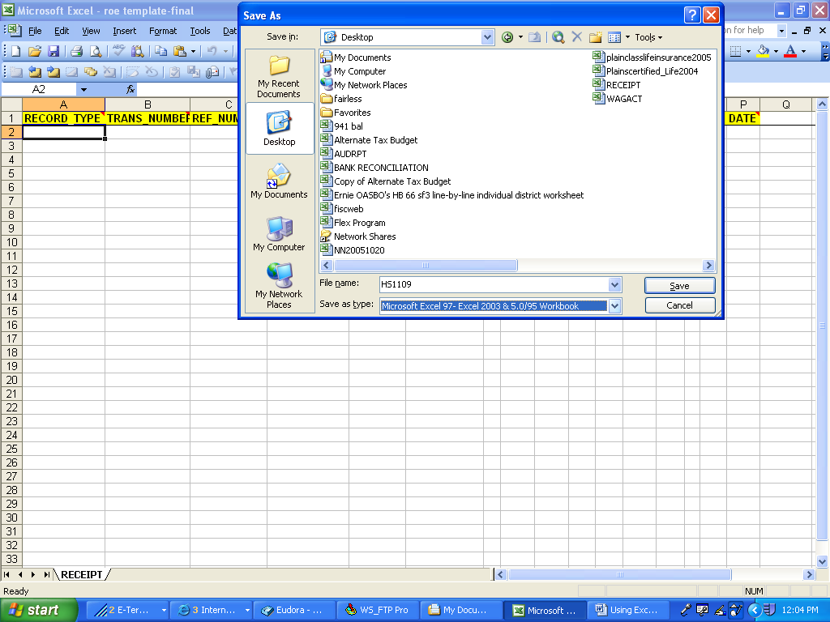

- Send the file to the Treasurer’s office.

