Before you begin…..

Attached are the instructions for the USAS system to automatically assign requisition numbers.

The instructions on the following two pages may be given to your staff. You may customize steps 2 and 3 for your district (how to name the file, where to save the file and who to email the file to).

The date entered in the Posting Date field in AUTOPOST will be the requisition date.

The template headers are password protected. If you would like the template customized for your district, please email fiscal_help@sparcc.org

Using Excel to Load Requisitions (System Automatically Assigns Requisition Numbers)

If the USAS system is going to automatically assign requisition numbers, the fields in the Excel template must be filled in as follows:

RECORD_TYPE: Enter RQ. Must be uppercase.

RQ_RECORD_TYPE: **OPTIONAL** Enter a G only if you are entering information in the DELIVERY_* FIELDS. The next line must have a RQ_RECORD_TYPE of D and contain only the detail lines (see example below).

REF_NUMBER: Enter a 1 for the first requisition, a 2 for the second, etc. If there are multiple items for one requisition, the REF_NUMBER remains the same.

TI: Enter 05. Make sure the leading zero appears.

FUND: Enter in the fund code. Make sure the leading zeroes appear.

FUNC: Enter in the function code. It must be 4 characters in length.

OBJ: Enter in the object code. It must be 3 characters in length.

SCC: Fill in if applicable. If data is entered, it must be 4 characters in length.

SUBJECT: Fill in if applicable. If data is entered, it must be 6 characters in length.

OPU: Fill in if applicable. If data is entered, it must be 3 characters in length.

IL: Fill in if applicable. If data is entered, it must be 2 characters in length.

JOB: Fill in if applicable. If data is entered, it must be 3 characters in length.

QUANTITY: Enter in the item quantity. If you enter a quantity greater than 1, the total price will not appear in the spreadsheet, but will calculate once the spreadsheet is loaded.

UNIT_PRICE: Enter in the price of the item.

DELIVERY_DATE: Optional delivery date. Must be entered as MM/DD/YYYY (slashes must be entered).

DELIVERY_NAME: The name of the delivery vendor.

DELIVERY_ATTENTION: The delivery attention line.

DELIVERY_STREET: The delivery street address.

DELIVERY_ADDRESS: The delivery address.

DELIVERY_CITY: The delivery city.

TERMS: The terms line.

ATTENTION: The attention line.

VENDOR: Enter the vendor number.

DESCRIPTION: Enter the item description.

REQ_DATE: The requested purchase order date. Must be entered as MM/DD/YYYY (slashes must be entered).

Example of using the General and Detail RQ_RECORD_TYPE:
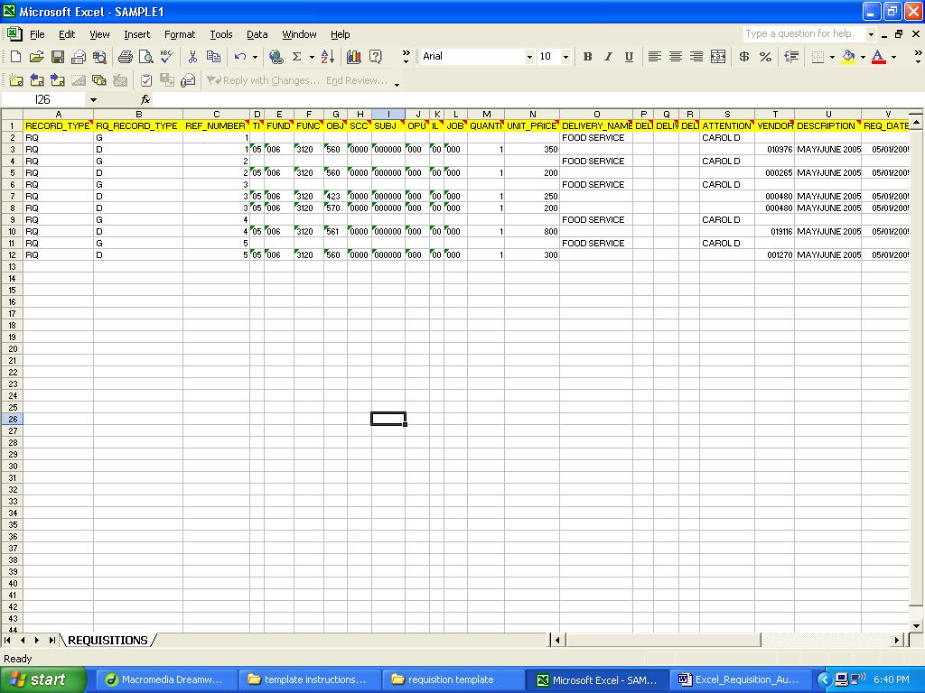

- Once you have entered all of the data in to the spreadsheet, you must do a File, Save As:
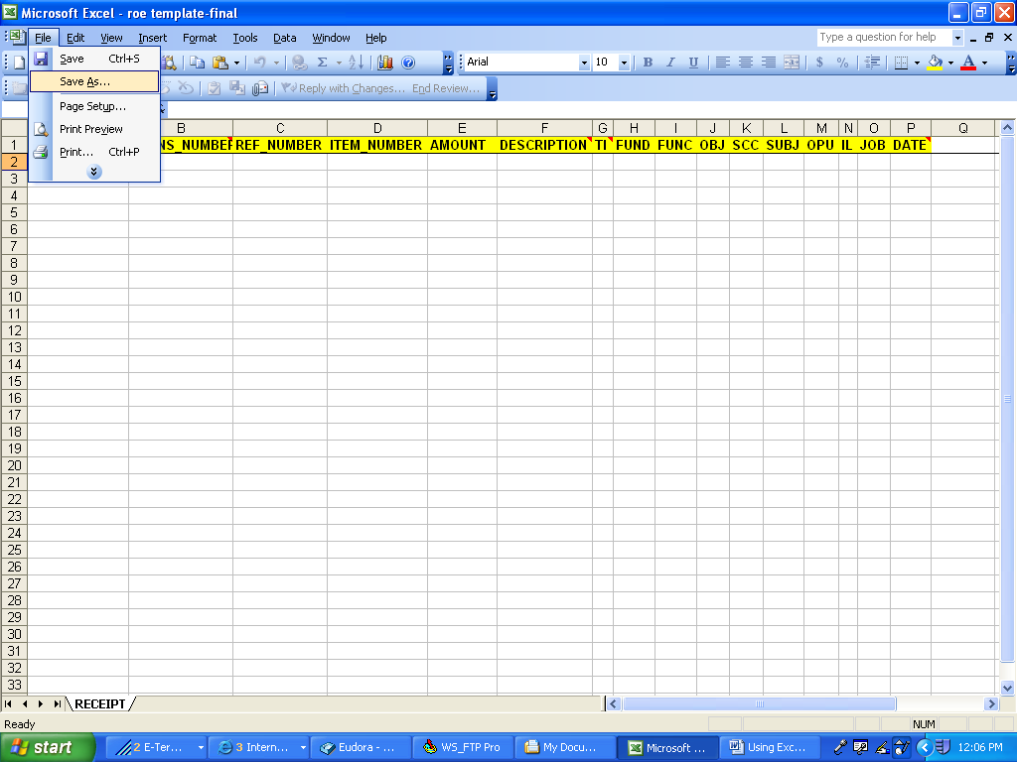

- Name the file accordingly (HS11052005) and save as an Excel file (note where you are saving it to – Desktop, server, etc).

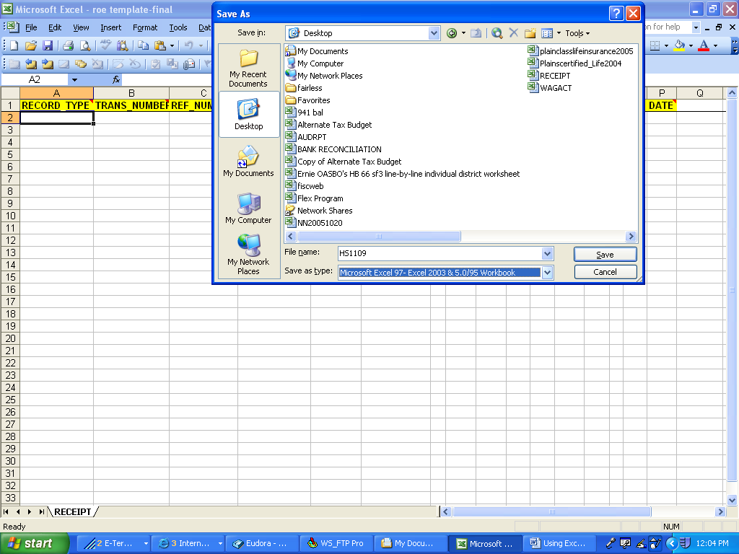

- Send the file to the Treasurer’s office.

