Before you begin…..

Attached are the instructions for manually entering the transaction (receipt) numbers on the reduction of expenditure spreadsheet.

The instructions on the following two pages may be given to your staff. You may customize steps 2 and 3 for your district (how to name the file, where to save the file and who to email the file to).

If a date is not entered on the spreadsheet, the date entered in the Posting Date field in AUTOPOST will be the assigned date.

If a date is entered on the spreadsheet, it will override the date entered in the Posting Date field in AUTOPOST. If you want the date taken off of the spreadsheet, please email fiscal_help@sparcc.org
Using Excel to Load Reduction of Expenditures
(Manually Assigning Transaction Number)

If you are going to manually assign the ref/exp transaction numbers, the fields in the Excel template must be filled in as follows:

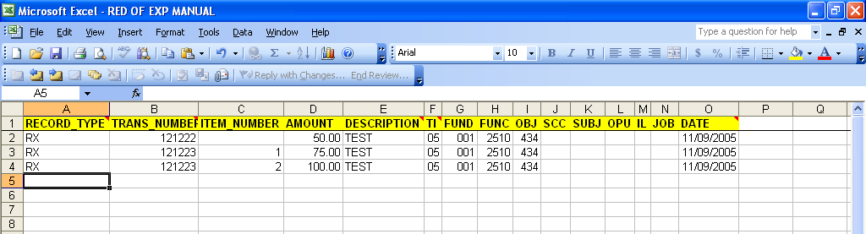

RECORD_TYPE: Enter RX. Must be uppercase.

TRANS_NUMBER: Enter in the beginning transaction number. If you are entering in multiple items for the same reduction of expenditure, you must fill in the ITEM_NUMBER field with the corresponding number (1, 2, etc.). The transaction number must be filled in each time (see example for transaction number 121223).

ITEM_NUMBER: If entering more than one item for a reduction of expenditure, this must be filled in accordingly. This may be left blank if there is only one item per reduction of expenditure number.

AMOUNT: Enter in the item amount of the reduction of expenditure item.

DESCRIPTION: Enter in the reduction of expenditure description.

TI: Enter 05 for a reduction of expenditure. Make sure the leading zero appears.

FUND: Enter the fund code. Make sure the leading zeroes appear.

FUNC: Enter the function code. It must be 4 characters in length.

OBJ: Enter the object code. It must be 3 characters in length.

SCC: Fill in if applicable. If data is entered, it must be 4 characters in length.

SUBJECT: Fill in if applicable. If data is entered, it must be 6 characters in length.

OPU: Fill in if applicable. If data is entered, it must be 3 characters in length.

IL: Fill in if applicable. If data is entered, it must be 2 characters in length.

JOB: Fill in if applicable. If data is entered, it must be 3 characters in length.

DATE: Fill in if applicable. Must be entered as MM/DD/YYYY (slashes must be entered).

- Once you have entered all of the data in to the spreadsheet, you must do a File, Save As:
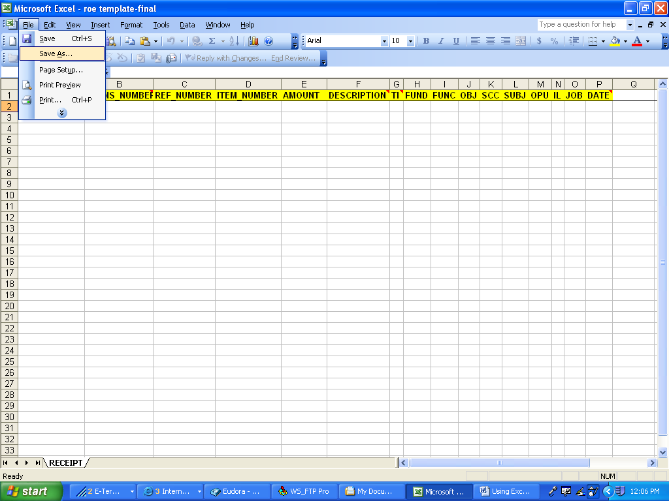

- Name the file accordingly (HS11052005) and save as an Excel file (note where you are saving it to – Desktop, server, etc).
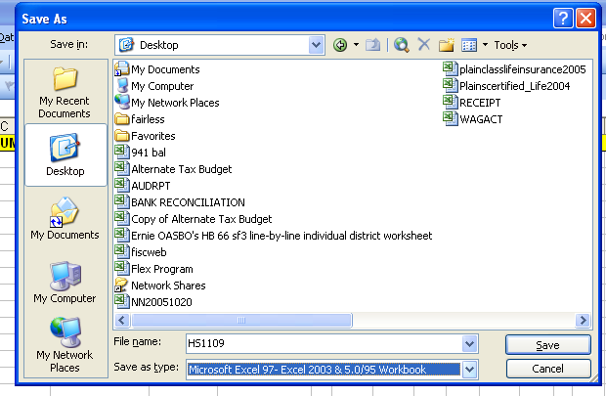

- Send the file to the Treasurer’s office.

