Using the Inventory Spreadsheet

All columns highlighted in yellow will automatically populate with the required data once the linked cells are filled in. You may override the data if it is not correct.

If you would like additional fields placed on the spreadsheet (replacement cost, insurable value, etc), please email fiscal_help@sparcc.org to modify the spreadsheet.

The spreadsheet will create a “generic” acquisition record. The check information, account, PO, etc will not show on the ACQTRN record. The PO number, etc can be filled in on the DESC2 field in the spreadsheet.

Do NOT enter disposals or transfers on the spreadsheet.

It is recommended that an EIS001 report is generated prior to entering data on the spreadsheet. The EIS001 is located on the EISRPT menu. It will list all of the codes that are set up in the EIS system.

Updating the LOOKUP worksheet

There are two tabs on the inventory workbook. The LOOKUP worksheet will need to be updated first.

1. Click on the LOOKUP tab:
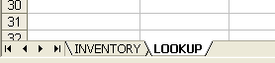

2. Locate the Item Category information on the EIS001 report. Enter in the Item Category in the
ITEM CATEGORY column and the applicable useful life in the USEFUL LIFE column:
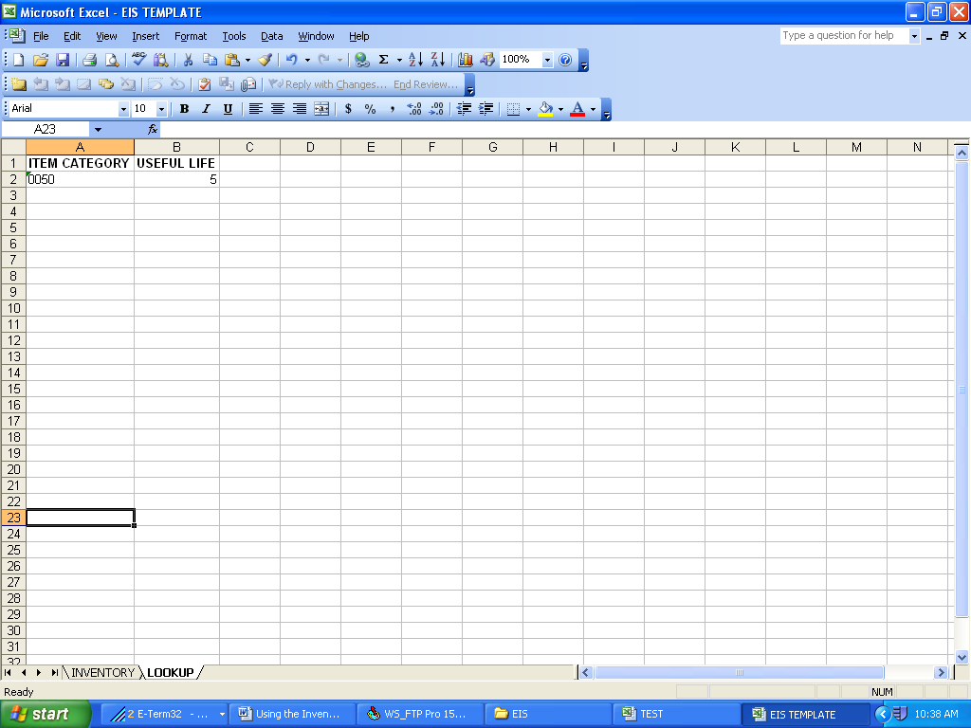

Updating the INVENTORY worksheet

1. Click on the INVENTORY tab:

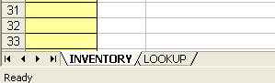

☹Do not change the Header columns. If the column headings are changed, the spreadsheet will not work.

- Enter the information on to the worksheet. The columns highlighted in yellow will auto populate with data. You may overwrite the data if it is incorrect. Once you enter data past row 5, it will take on the same characteristics as rows 2-5 (fields will be highlighted in yellow, etc). Please enter your first tag number in cell B2.

- Below is an explanation of the information that should be entered in each column:
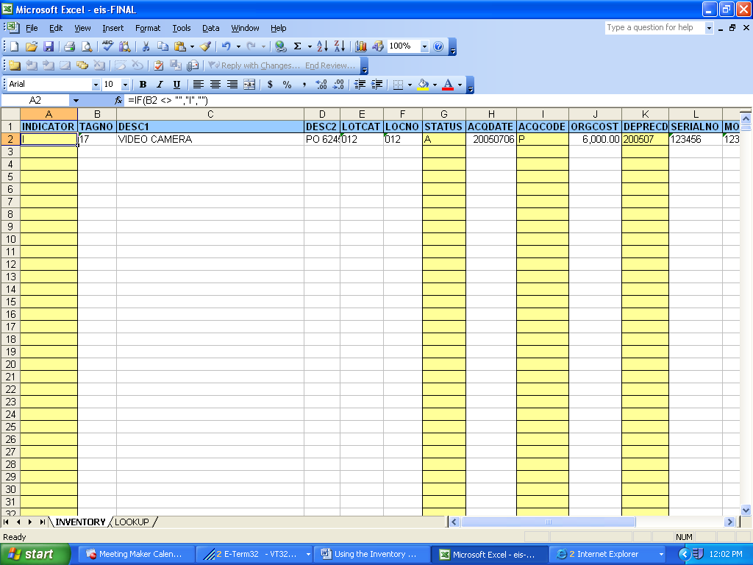

INDICATOR: Will auto populate once the tag number is entered.

TAGNO: Enter in the tag number. If the tag number contains leading zeroes, you
must enter them in. Maximum of 12 characters.

DESC1: Enter in a description of the item. Maximum of 40 characters.

DESC2: Enter in additional description information (optional). Maximum of 40
characters.

LOTCAT: Enter in the location category

LOCNO: Enter in the location number.

STATUS: An uppercase A will auto populate once the tag number is entered.

ACQDATE: Enter in the acquisition date. Must be entered in as YYYYMMDD (20050428).

ACQCODE: A P for purchased will auto populate once the tag number is entered. However, the following codes are available:

D – Donated
L – Leased
O – Other
P – Purchased

ORGCOST: Enter in the cost of the item.

DEPRECDATE: Will auto populate once the ACQDATE is entered.

SERIALNO: Optional field. Enter in the serial number of the item.

MODELNO: Optional field. Enter in the model number of the item.

ITEMCAT: Enter the item category.

ORGUNIT: Enter the organizational unit.

CLASS: Enter in the asset class.

FUND: Enter in the 3 digit fund.

FUNCTION: Enter in the 4 digit function.
DEPRECMETHOD: This will auto populate with an S. The S can be changed accordingly.

LIFE: This will auto populate with the information set up in the LOOKUP tab.

CONDITION: This will auto populate with a G. The G can be changed accordingly.

ITEMSINLOT: Enter the number of items in the lot.

Saving the Inventory Spreadsheet

The first time you save the inventory spreadsheet, select File and Save As. If you make any changes (i.e. overwrite formula’s etc, you will have the original spreadsheet and will not have to download another copy):

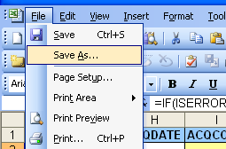

After you have “saved as”, you can save the spreadsheet as usual (File, Save).

Once you have completed the spreadsheet, email it to fiscal_help@sparcc.org and we will load the file in to a demo for you to verify.

Changes to EIS Once the File is Loaded

Once the file has been loaded in to the demo, there will be a couple of reports that you will need to verify. The first report is the EISADD.TXT. It will list all records that were loaded. If there are errors, the EISERR.TXT will be created. The records on the EISERR.TXT can be corrected on the spreadsheet and reloaded or the changes can be made in EIS. Do not make any corrections or updates in EIS until the spreadsheet has been loaded in to your live files.

Once the information is correct in the demo, the Treasurer will need to email fiscal_help@sparcc.org and let us know that the spreadsheet can be loaded in to the live files. Once the spreadsheet is loaded we will send an email notifying you that the information can now be updated if necessary.

